Model Explanation
Linear Model Initial Testing: Given our team’s scope of predicting passenger flow through major airports, our model is classified as a regression task. With a given dataset of features related to airport operations such as specific airport, checkpoint, date and hour, our team wants to predict a continuous value (total passenger count). To first establish a baseline performance and experiment with a linear model, we tried ordinary least squares, ridge and lasso regression to understand the associated performances under each of these models. Given the complexity of airport operations such as certain hours being associated with “customer flow spikes” and dozens of checkpoints associated with their own unique names, both the linear models were not able to optimally capture these data aspects and the ridge / lasso regularization faced difficulty summarizing patterns even after “one-hot encoding” the airport categorical variables. Additionally, various columns in our data have different scales, and even after standardization the initial linear models we tried experienced difficulty with columns such as “hourlyDepartureCount, AvgLoadfactor, and daystoNearestHoliday.” Our code is structured in the following stages: 1) Reading the appropriate csv files, 2) Loading Data Functions, 3) Ensuring feature engineering, 4) Categorical encoding, 5) Train / validation / test, 6) Baseline Calculation 7) Training the model8) Test set Evaluation, 9) Results

Gradient Boosted Decision Trees: For an overview, our team found that gradient boosted decision trees were the most optimal method due to its ability to generate trees that capture multiple airport features (such as ATL + hour 6 +weekday = high throughput"), its ability to handle categorical features directly (such as airport checkpoint names), robustness for feature scales (normalization not needed), and faster computing efficiency time.

Model Metrics: From computing the necessary dataframe merges, our dataset is 3,159,423 rows with 960 airport-year-month-combos. The 12 features can be broken down into three categories of “category”, “features”, and rationale, and our team utilized a strict chronological split to ensure accuracy given the time-series and forecasting nature associated with airports. To summarize our train, validation and test split, our training data consists of all data before the last 120 days of the dataset, our validation set consists of the subsequent 60 days after and the test set includes the final 60 days that was never exposed to the model during training or tuning. Additionally, our feature matrix provides adequate splits of data to carry out our model testing.

Hyper Parameter Tuning: We tuned several key hyperparameters to optimize our LightGBM model. From various values of learning rate, number of leaves, and minimum child samples, we evaluated each combination on the validation set and selected the configuration that minimized validation RMSE. Our final settings: a learning rate of 0.05, 127 leaves, and a minimum of 50 samples per leaf allowed our model the best balance between model complexity and generalization. In contrast to manual experimentation, early stopping allowed us to effectively evaluate our model and prevented overfitting to the training data.

Baseline Metrics: Our team wanted to establish a baseline to compare our model performance. This “naive baseline” represents what a human planner might do without any ML system and is emulated through the mean throughput across all matching rows in the training data (same airport, same checkpoint, same day of week, same hour, same month.

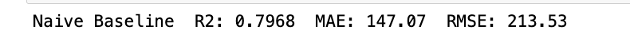

Gradient Boosted Decision Trees: We evaluate our model using four complementary metrics, chosen to align with both standard ML evaluation practices and the prior literature on airport passenger flow forecasting (Monmousseau et al., 2020):
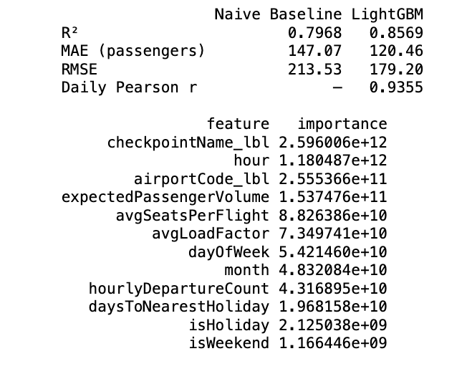
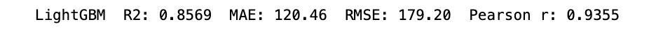
R² (Coefficient of Determination): As R² measures the proportion of variance in passenger throughput explained by the model this value of 0.856 means the model explains 85.6% of the variability in hourly throughput across airports and checkpoints. This means our model is likely reliable for TSA staffing, which translates to better-calibrated staffing levels (fewer overstaffed quiet hours, fewer understaffed rush hours) especially given the recent travelers’ frustration in the news.

MAE (Mean Absolute Error): As MAE is the average absolute difference between predicted and actual passenger counts, in the original unit (passengers), our MAE is directly interpretable: the value of 120.46 above means predictions are off by ~120.46 passengers on average per checkpoint-hour. TSA planners can use this to set staffing buffers. For example, if the model predicts 400 passengers, they know to plan for roughly 280–520 approximately.

RMSE (Root Mean Squared Error): As RMSE is similar to MAE but penalizes large errors more heavily (due to squaring), this value is important for staffing: a prediction that's off by 500 passengers in a single hour is operationally much worse than being off by 50 passengers in 10 separate hours, even though the total error is the same. RMSE captures this asymmetry. RMSE is also the metric used for early stopping during training. Form our output, the RMSE is 179.2, which is slightly higher than our MAE and means our model can occasionally make higher errors in passenger count.

Daily Pearson Correlation (r): Following Monmousseau et al. (2020), we aggregate predictions and actuals to the daily level (summing across all airports, checkpoints, and hours) and compute the Pearson correlation coefficient. Our Pearson Correlation value of 0.9355 means our model reliably identifies which days will be busy vs. quiet, even if individual hourly predictions have some noise. This number means our output correctly tracks day-to-day fluctuations in total system demand, which are all critical for system-wide staffing decisions and expected passenger flow across airports.

Summary: Together, these four metrics provide a comprehensive picture: R² and Pearson r assess overall explanatory power, MAE gives a human-interpretable error magnitude, and RMSE ensures we're not hiding large outlier errors behind a good average. Lastly, it seems from the output that three features (checkpoint name, hour, and airport code) are the most important predictors of passenger flow. This makes sense since certain checkpoints likely have an associated number of passengers depending on accessibility (TSA pre, general, private) while hour heavily impacts likelihood of red-eye flights or peak times. Lastly, airport locations (code) vary by associated surrounding population and related number of flight offerings that would impact passenger flow (NYC JFK is a hub for both domestic and international flights compared to smaller domestic airports with less flight options. .

Reproducibility:
All code is version-controlled on GitHub (https://github.com/arendcolle/ml-bus-project.git) and can be run as a plain Python script or cell-by-cell in VS Code/JupyterLab. The data is also hosted on GitHub. To reproduce:

- git clone repository
- Install dependencies (see Appendix B for full package versions)
- Place source CSVs in the expected directories: throughput data/, ontime data/, and bts data/ (see Appendix B for file naming patterns)
- Run modelTraining.py top to bottom
- The trained model saves automatically to models/lgbmModel.pkl. This file contains the LightGBM model, fitted label encoders for airport and checkpoint, the feature list, and the test set metrics, and is used downstream for inference.

The train/val/test split is hardcoded (final 60 days = test, prior 60 days = validation), so running on the same data reproduces identical splits and metrics.

Model Assets: Throughout the notebook, output includes 1) the breakdown of data files used (throughput, on-time, bts files), 2) shape of the data such as throughput rows, airport-date-hour, and airport-year-month, 3) Naive Baseline statistics (R2, MAE, RMSE), 4) early stopping output during training, 5) LightGBM statistics (R2, MAE, RMSE, Pearson r) and 6) a summary dataframe of the results comparing baseline and lightGBM + feature and associated importance for each. Additionally after training completes, the code saves everything into a single file called models/lgbmModel.pkl. This file packages together the trained LightGBM model, the airport and checkpoint encoders, the feature list, and the final test metrics in one place. All of our code is on GitHub so anyone on the team can clone it, install the dependencies, and reproduce the exact same model.

Exhibit A: Team commentary for collaborative alignment
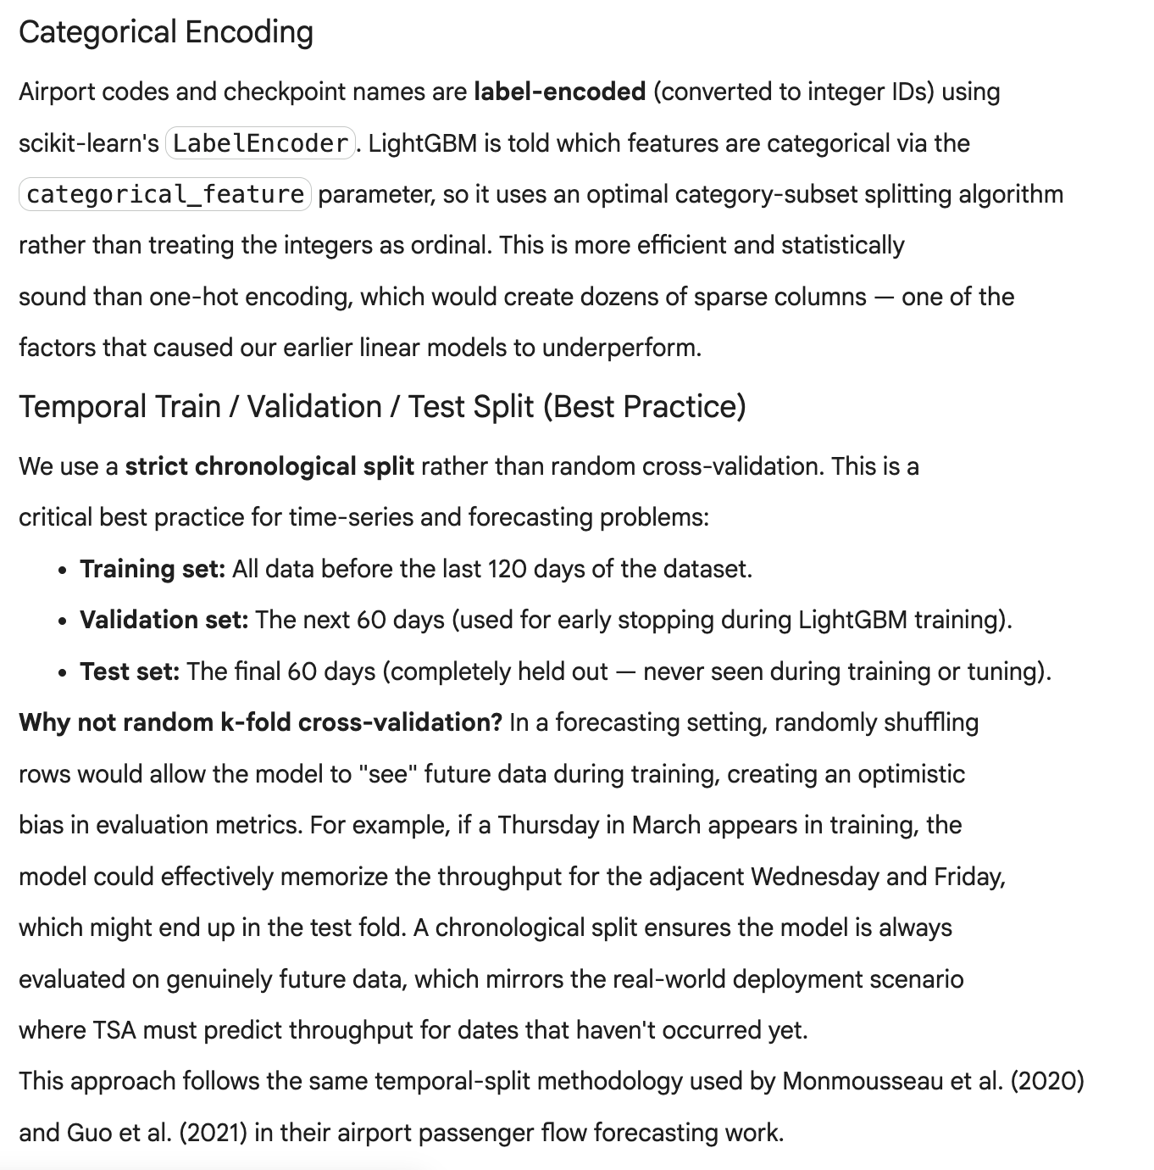

Exhibit B: Package versions
Data setup: Clone the repository (also has the data: https://github.com/arendcolle/ml-bus-project)
- throughput data/TsaThroughput.*.csv (TSA FOIA throughput files)
- ontime data/ontime_*.csv (BTS on-time performance CSVs)
- bts data/*.csv (BTS T-100 domestic segment CSVs)
Package | Version
lightgbm | 4.6.0
scikit-learn | 1.5.2
pandas | 2.2.3
numpy | 2.0.1
scipy | 1.14.1
holidays | 0.93
joblib | 1.4.2
Install via: pip install lightgbm==4.6.0 scikit-learn==1.5.2 pandas==2.2.3 numpy==2.0.1 scipy==1.14.1 holidays==0.93 joblib==1.4.2

